**Yougurt Bootstrap website**

**How to customize the website navbar in bootstrap 4 ?**

After removing the unnecessary button through inspection , our nav bar is looking like this –

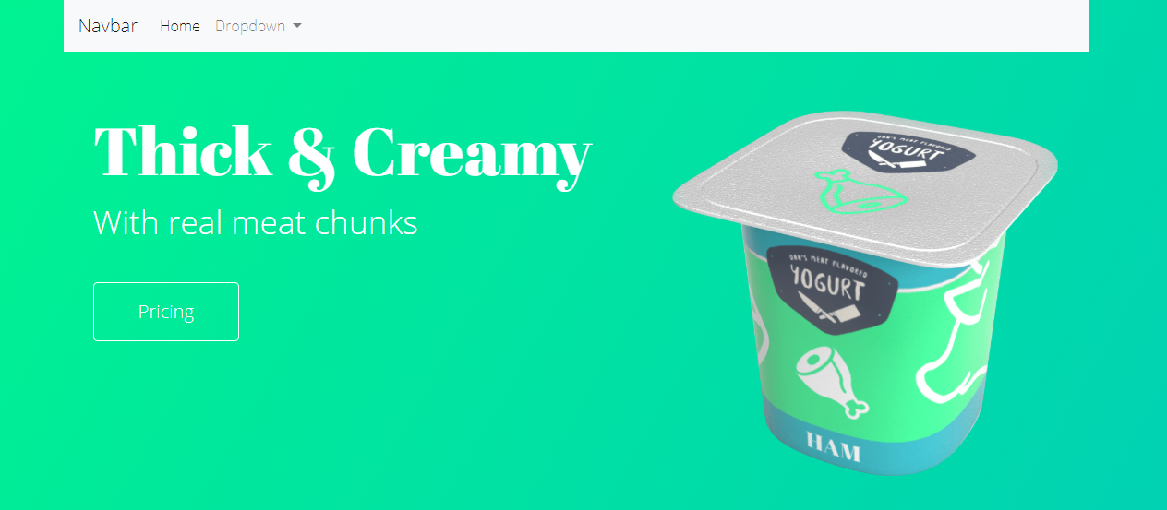

Now, Our challenge is to take the Home and Dropdown button to the right portion of the bar.

Just by simply inspecting , we can see that , both of the button lies under the unorder list –

<ul class="navbar-nav"> <<<<<<<<<<<

                    <li class="nav-item active">

                        <a class="nav-link" href="#">Home <span class="sr-only">(current)</span></a>

                    </li>

                    <li class="nav-item dropdown">

                        <a class="nav-link dropdown-toggle" href="#" id="navbarDropdown" role="button"

                            data-toggle="dropdown" aria-haspopup="true" aria-expanded="false">

                            Dropdown

                        </a>

                        <div class="dropdown-menu" aria-labelledby="navbarDropdown">

                            <a class="dropdown-item" href="#">Action</a>

                            <a class="dropdown-item" href="#">Another action</a>

                            <div class="dropdown-divider"></div>

                            <a class="dropdown-item" href="#">Something else here</a>

                        </div>

                    </li>

                </ul>

So just add ml-auto to the class !

 <ul class="navbar-nav ml-auto">

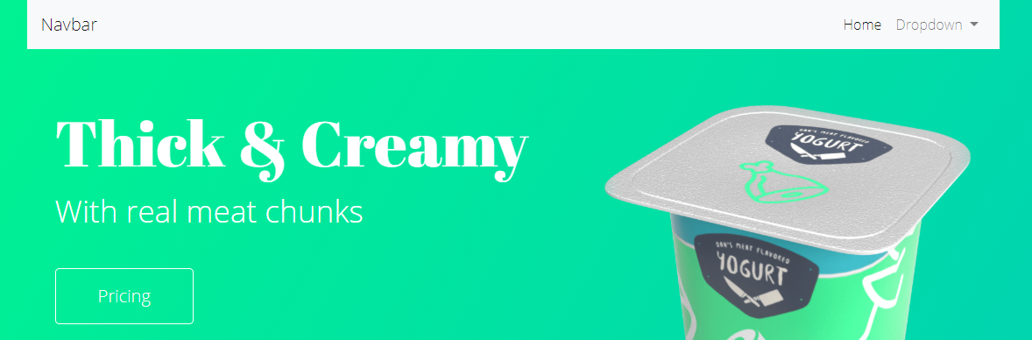

Now, we wanna add our own logo to the Navbar.

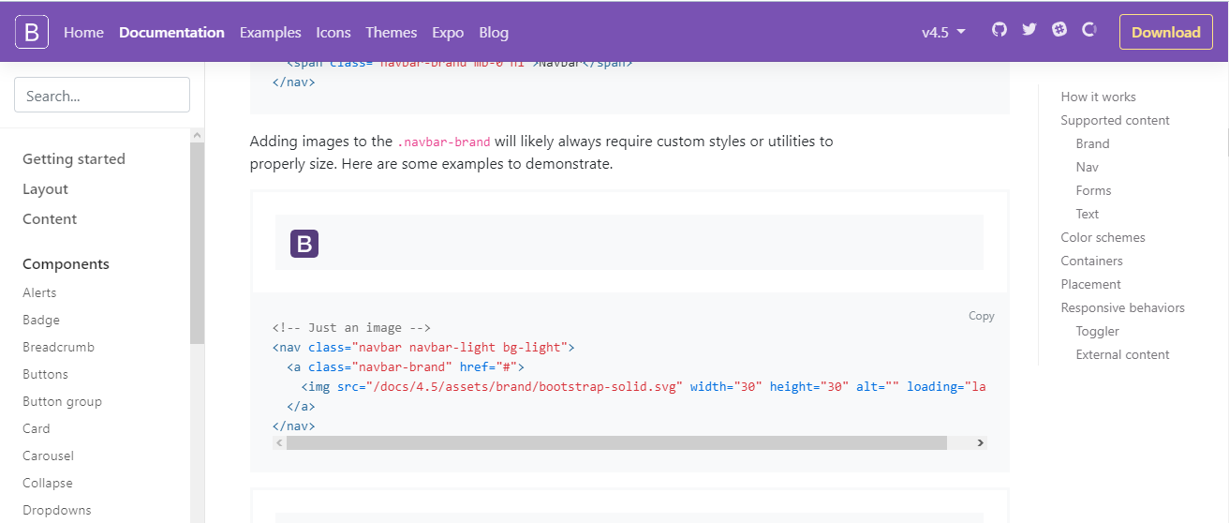

This is what the documentations says to us.

<a class="navbar-brand" href="#">Navbar</a>

So delteing this line and copy and pasting from documentation

  <nav class="navbar navbar-light bg-light">

                <a class="navbar-brand" href="#">

                    <img src="images/logo-dans-meat-yogurt.svg" width="30" height="30" alt="" loading="lazy">

                </a>

            </nav>

Now our site looks like,

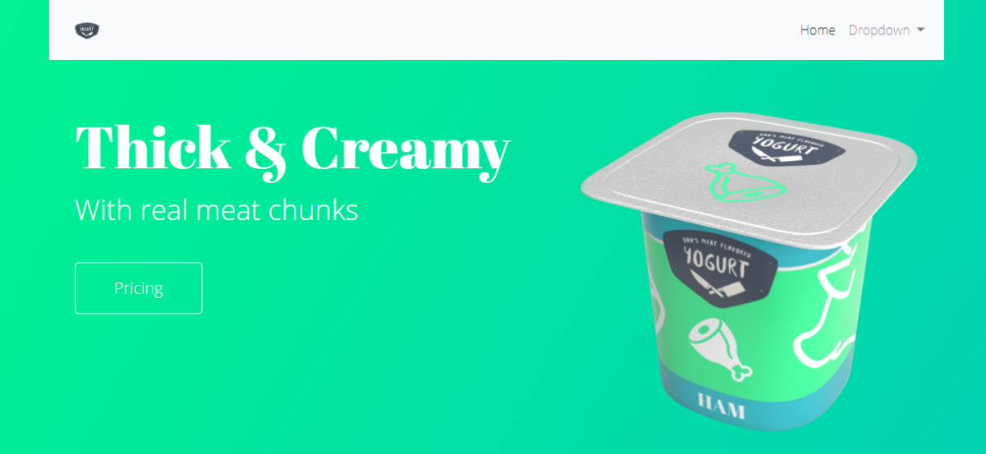

Remove , width="30" height="30" to get the actual size of the logo .

Let’s remove the white background now in the navbar .

*<!-- Navigation  -->*

        <nav class="navbar navbar-expand-lg navbar-light bg-light">

*<!-- Just an image -->*

            <nav class="navbar navbar-light">

                <a class="navbar-brand" href="index.html">

                  <img src="images/logo-dans-meat-yogurt.svg" alt="Dans' Meat Yogurt Company Logo">

                </a>

              </nav>

Just remove the class bg-light ( red marked) from the nav. And our nav bar will be completelty see through.

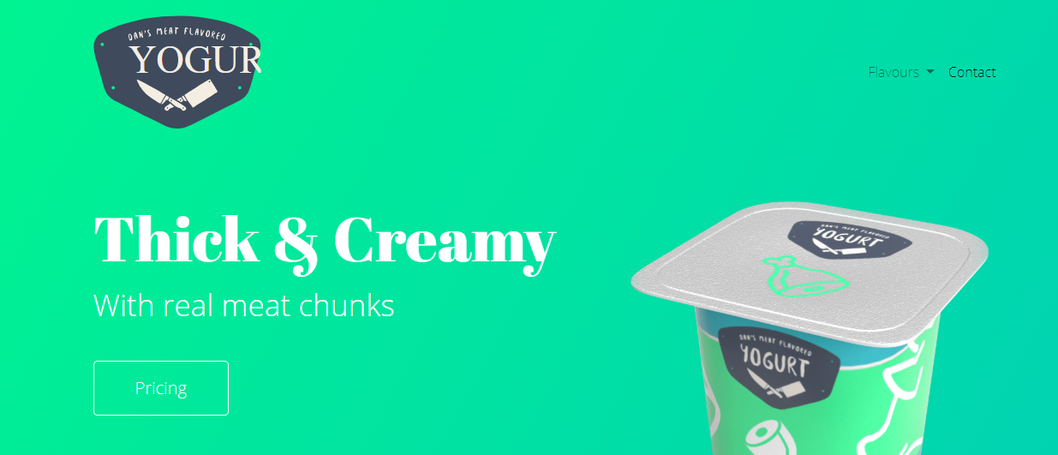

We have renamed the dropdown to flavors and home to contact !

Now, we wanna make our flavors and contact button exactly be the same like the pricing button.

So simple . Just copy and paste the class that controls the pricing button ( insider our jumperton).

 <li class="nav-item btn btn-outline-light">

                        <a class="nav-link text-white" href="#">Contact</a>

                    </li>

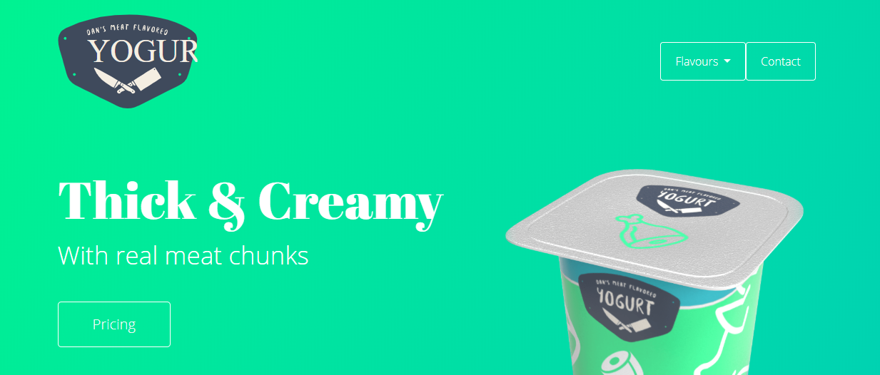

So, we need to add some spacing beetween flavors and contact .

It can be done in two ways. Select the class controling flavors and apply mr-4

Pr, select the class controling contact and apply ml-4

  <li class="nav-item btn btn-outline-light ml-4">

                        <a class="nav-link text-white" href="#">Contact</a>

                    </li>

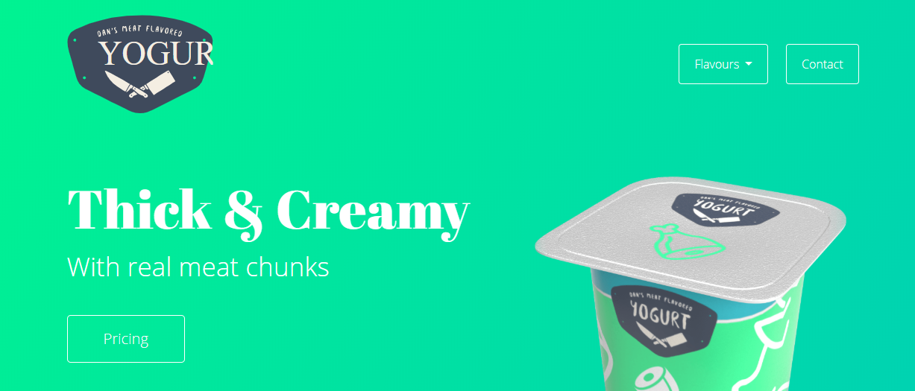

Nice !

But it has already created a problem in mobile view ! 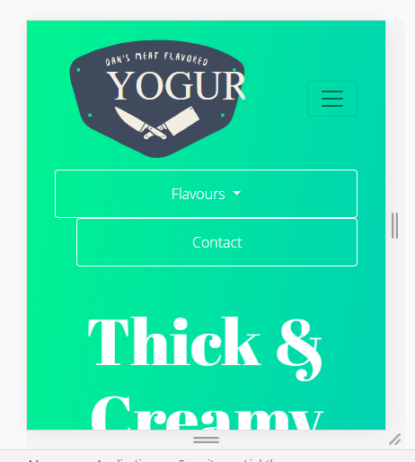

To fix that issue, write that, in mobile view, there is no margin to the left. It will start from the medium .

[ in some rare cases, try float-right/ float-left ]

   <li class="nav-item btn btn-outline-light ml-0 ml-md-4">

                        <a class="nav-link text-white" href="#">Contact</a>

                    </li>

Now, Lets make our navbar sticky to the top .

Just write sticky-top to the nav bar .

 <nav class="navbar navbar-expand-lg navbar-light sticky-top">

**Now, we will add founder message along with e pic just before our carousel .**

*<!-- Founder message  -->*

        <div class="row">

            <div class="col-12 col-md-4">

                <img src="images/headshot-dan.jpg" alt="" class="img-fluid rounded-left">

            </div>

            <div

                class="col-12 col-md-8 bg-white p-5 d-flex align-items-center border border-dark rounded-right">

                <section >

                    <h2>Message From Founder</h2>

                    <p>Lorem ipsum dolor sit, amet consectetur adipisicing elit. Nesciunt autem suscipit aperiam ex quae

                        minus earum blanditiis distinctio cupiditate corrupti dolorum minima ipsum quisquam vero itaque,

                        totam quam nihil error! Voluptatum voluptates suscipit atque nobis accusantium, enim quod

                        possimus numquam rerum. Eveniet officia officiis voluptas facere voluptatum labore! Minima

                        consequatur dolore non corporis excepturi labore quam dignissimos accusamus nulla vel!</p>

                </section>

            </div>

        </div>

*<!-- Founder message  -->*

We have used the class “img-fluid” to make our image repsonsive .

We have divided the col-12 for mobile screen in both image and text message part. But for medium view. The ratio will be 4:8 !

<div

                class="col-12 col-md-8 bg-white p-5 d-flex align-items-center border border-dark rounded-right">

bg-white : background white

d-flex align items-center : to keep the text align in the center.

Border : there will be a border

Border-dark : the border will be of dark color.

rounded-right : border rounded at the right part .

Now, we have to turn off the caresoul for the mobile view and turn it back on the mobile view.

*<!-- carousel -->*

        <div id="carouselExampleControls" class="carousel slide d-none d-md-block" data-ride="carousel">